Tiogue Elementary School

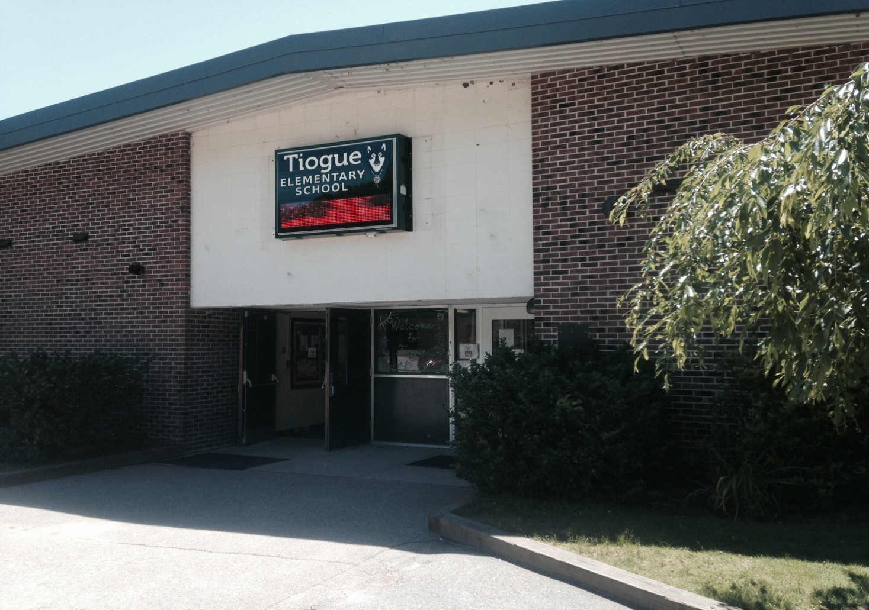

School Improvement Plan 2014-2018

School Improvement Planning and Monitoring Process –ELA Tiogue

Result Statement: Specific Target: Expected Increments of Gains:
Students will be able to read and Reduce the number of students 3% annual increase of students who
reflect upon literature that was read. who do not meet or exceed ELA meet or exceed the expectations
Students will demonstrate proficiency Common Core standards of the ELA State Assessment. (2015 Data as Baseline)
in reading and in writing.
TACTIC/  OBJECTIVE FOR SCHOOL CHANGE (change in student behavior) | EVIDENCE OF NEED | CHANGING INSTRUCTION | MONITORING PROCESS with TIMELINES and ADJUSTMENTS | COLLABORATION, SUPPORT, and SCHOOL/DISTRICT RESOURCES | EVALUATION AND EXPECTED OUTCOME (reporting out)
- All students will participate in a balanced literacy program as outlined by the Common Core and ELA curriculum;  including adherence to district based initiatives such as a phonics program grades K-2.  - Students will be assessed using STAR and DRA 2  data. At risk students will be targeted with interventions to decrease the number of PLP’s.  - Students will know and understand the target/objective of each lesson.  - Students will be able to demonstrate academic expectations across all content areas.  - Students will be engaged in higher level literacy activities such as the analysis and interpretation of text across all content areas.  - Students will use comprehension and questioning strategies to think and respond critically about text.  - Students will develop metacognitive strategies.  - Students will apply word ID and oral reading fluency techniques when reading new text or rereading familiar texts.  - Students will write for a variety of purposes and genres including response to text, narrative, expository, persuasive, poetry, procedural, journal, reports, etc.  - ULSS students at the Tier 3 Level will be part of the NCII project to improve Reading comprehension including new strategies, programs, and interventions. | - State Assessments  NECAP  Reading  Elementary Grades Grade 3  Proficient 75%  Grade 4  Proficient 84%  Grade 5  Proficient 87% (+10%)  State Assessments  NECAP  Writing  Elementary Grade 5 (Reflects K-4)  Proficient 72%  (+10%)  - NECAP School Accountability Ranking: Warning; 10/12 targets achieved.  - ULSS students 1.3% deficient in ELA.  - School-Based Assessments:  ~ DRA 2  ~ STAR  ~ Formative  Assessments  ~ GOM’s  ~ Anecdotal  Information  ~ Report Card  Grades | - Scheduling of classroom time to facilitate the implementation of a balanced literacy approach with differentiated instruction (reading and writing each day).  - Implementation of direct instruction of comprehension strategies for understanding both fiction and informational text with modeling of appropriate written response in all curriculum areas. (Ex. Nancy Boyles work).  - Model implementation of Bloom’s Taxonomy: questioning strategies and stems.  - Continue Extended Day Kindergarten program to allow for increased literacy time.  - Embed & engage reading and writing throughout all content area.  - Institute Reading Academies for students performing below grade level in reading (funding dependent).  - Implementation surrounding response to non-fiction text (including the use of science notebooking).  - Have clear objectives identified and displayed for students & establish purposes for reading and writing.  - Model metacognitive strategies.  - Provide differentiated instruction through daily guided reading, incorporating student learning styles and needs.  - Establish purposes for reading and writing.  - Conference with students regularly in the reading and writing process.  - Take regular anecdotal records to gauge student reading progress.  - Provide models of student work and celebrate published work.  - Engage students in project based learning or choice of projects to demonstrate comprehension as well as opportunities for cooperative learning.  - Provide reading interventions or provide feedback to Interventionists as needed. | - Understanding of Reading and Written Common Core standards and knowledge of district curriculum as it is developed.  - Ongoing examination of STAR, other gathered data, and student work to assess academic rigor of assignments and the alignment to the Common Core and district curriculum as it is developed.  - Students will be assessed  with…  ~DRA 2 - up to 3x’s yearly  ~STAR- up to 3x’s yearly  ~Formative assessment –  ongoing  ~GOM’s – ongoing  ~Anecdotal Information –  ongoing  - Other district mandated assessment will be administered yearly (i.e. STAR) and analyzed to identify students in need of supplemental/remedial programming.  - Teachers analyze data and look at effective instructional strategies.  - Teachers use STAR and Aspen to track interventions in the Tier 1 setting.  - Data review scheduled regularly to analyze data and make instructional decisions. | - Continuous & on-going professional development including faculty meetings, and district led PD focused on maintaining reading achievement, written and oral communication in accordance with Common Core and new ELA curriculum.  - Continued allocation of funds to purchase professional texts for daily access by teachers in the professional library.  - Additional monies budgeted for guided reading texts (and classroom libraries) that are highly motivational and equitable across classrooms.  - The use of STAR and data to identify struggling students and consult on research-based instructional strategies by the Reading Specialists or Professional Development Coordinators.  - Staff will continue to engage in discussion to examine student work and reflect on teaching practice.  - Identify and allocate funding for Reading Academies and other supportive programs for struggling students (Title1).  - Adhere to all Title 1 Grant requirements: offering supplemental reading instruction to struggling students and providing parent workshops for families.  - Schools will receive support for continued RtI and the use of ASPEN for tracking data. | - Teachers will increase their understanding of teaching the Common Core and district curriculum in all content areas.  - District and StateTesting reading and writing scores will increase by 3% proficiency and decrease in partially proficient & substantially below proficient, particularly our ULSS subgroup.  - Gains in students meeting benchmarks on district and state assessments, particularly our ULSS subgroup.  - PLP updates  - Information presented at conferences and school report night.  - Continuous display of authentic work.  - DRA2 scores must meet district grade level benchmarks.  - Data will be presented to faculty, staff, students, families, and the community through alternate modes of communication (i.e. newsletters, email, etc.,).

School Improvement Planning and Monitoring Process- Mathematics Tiogue

Result Statement: Specific Target: Expected Increments of Gains:
Students will demonstrate math Reduce percentages 3% annual increase of students of
achievement in numeracy, of students by 3% who do not meet or exceed students who meet or who exceed the
computational skills, problem solving, math GLEs/GSEs/Common Core Standards standard on the Math State Testing. (2015 Data as
algebra, geometry, and data/statistics. Baseline)

TACTIC/OBJECTIVE FOR SCHOOL CHANGE (Change in student behavior) | EVIDENCE OF NEED | CHANGING INSTRUCTION | MONITORING PROCESS with TIMELINES and ADJUSTMENTS | COLLABORATION, SUPPORT, and SCHOOL/DISTRICT RESOURCES | EVALUATION AND EXPECTED OUTCOME (reporting out)
A. Create a comprehensive standards-based instructional program with a particular focus on teaching problem solving, concept application, and Common Core across all grade levels. Math Target maps have been created and are currently under review.  B. Increase computational skills through repetitive tasks.  C. Successful completion of word problems integrated into math curriculum (district level change)  D. Oral and written explanations to improve math communications.  E. Successful completing of common tasks/targets in math.  F. Students will be assessed using STAR testing and common district assessments. At risk students will be targeted with interventions to help close the gap.  G. Research and implement technology programs and applications that support student achievement and intervention goals.  H .ULSS students at the Tier 3 Level will be part of the NCII project to improve Reading comprehension including new strategies, programs, and interventions.  . | A. State Assessments  NECAP – Math  Proficient (Levels 3 & 4) - - Grade 3 69%  -Grade 4 74%  -Grade 5 76%  B. School-Based Assessments:  - End of unit tests aligned to CCSS  - STAR  % of students who do meet the benchmarks  % of students who do meet the benchmarks  - Report Card Grades  % of students meeting expectations is higher than  % of students below expectations  - NECAP School Accountability Ranking: Warning; 10/12 targets achieved.  - ULSS students 1.3% deficient in Math. | A. Scheduling of classroom time to facilitate the implementation of a comprehensive math program with differentiated instruction.  B. Implementation of direct instruction of comprehension strategies for problem solving.  C. Examine the half-day Kindergarten program in terms of schedule to allow for maximum math time.(Aligned to Common Core Standards)  D. Institute Math Academies for students performing below grade level in math (funding dependent).  E. Changing instruction as math maps and targets (curriculum) are examined and updated  F. Have clear objectives identified and displayed for students.  G. Model meaningful discussions through the use of higher level questioning. (Bloom’s Taxonomy)  H. Integrate mathematics into content areas where applicable.  I. Provide differentiated instruction through purposeful math groupings and the use of manipulatives.  J. Take regular anecdotal records to gauge student progress on math targets.  M. Provide models of student work.  N. Use RtI blocks to remediate low performing targets and STAR Data or provide feedback to Interventionists as needed.( Results to be shared through Data Review Meetings) . | A. Understanding of math CCSS and knowledge of district curriculum (grade level target maps).  B. Ongoing examination of student work to assess academic rigor of assignments, quality of rubric, and the alignment to CCSS and district curriculum (grade level target maps).  C. Understanding and creating lessons along with the GO Math series to address math targets.  D. Understanding of assessments (common tasks, end-of-course assessments, portfolio work) that are aligned to the math Common Core and district target maps.  E. Annual State Testing results monitored.  F. E. F. Analysis of STAR and end of unit data to create RtI groups for remediating numeracy targets.  G .Work with the district math coach (if available) and PDC to enhance Tier 1 and 2 instruction and identify students who require supplemental math interventions.  H. Grade and discipline specific data blocks scheduled regularly in order to analyze data and make instructional decisions. | A. Continuous & on-going professional development including faculty meetings, Data Review meetings, Professional Development meetings, and district led PD focused on maintaining math achievement in accordance with Go Math series, district target maps and using Math Interventionist in all grade levels.  B. Continued allotment of funds for purchase of math materials (i.e. specific program materials (Touch Math, Investigations) manipulatives).(funding dependent)  C. Continuous training on the use of formal assessments to identify (STAR) struggling students.  D. Professional Development will continue regarding appropriate math instruction through Professional Development Coordinators (district) and Math Interventionist in all grade levels.  E. Staff will continue use of Data Review meetings to engage in discussion to examine student work and reflect on teaching practice.  F. Identify and allocate funding for Math Academies and other supportive programs for struggling students.  G. Schools will receive support for continued use of Aspen and STAR to track and analyze student data.  H. Support from building based math coach if available and/or PDC for classroom instruction strategies and individual student intervention support. | A. Teachers will Increase their understanding of teaching the Common Core and district curriculum in all content areas as observed in teaching practice through Dana Center walkthroughs.  B. Annual gains on state Math assessments at all grade levels for all students.  C. Proficient scores on end of unit and district common assessments for all students.  D. Gains in students meeting benchmarks on all STAR screens (trimester local assessments) for all students.  - District and StateTesting Math will increase by 3% proficiency and decrease in partially proficient & substantially below proficient, particularly our ULSS subgroup.  - Gains in students meeting benchmarks on district and state assessments, particularly our ULSS subgroup.  G.. Information presented at conferences and school report night.  - Continuous display of authentic work.  - Data will be shared out to faculty, staff, students, families, and the community through alternate modes of communication (i.e. newsletters, email, etc.)

School Improvement Planning and Monitoring Process P.B.I.S.--Tiogue

Result Statement: Specific Target: Expected Increments of Gains:
Maintain and environment where Reduce percentage of students who Increase percentage of students who
Everyone feels safe, respected, are referred to PBIS/Behavior Specialist/Targeted. adhere to school-wide rules without
responsible and ready to learn. Team for intervention and support <80%. intervention and support >80%.
B- Be Kind
R- Responsible Behavior
A – Always Ready to Learn
V – Value Yourself and Others
E – Everybody is Somebody at Tiogue! .

TACTIC/OBJECTIVE FOR SCHOOL CHANGE (Change in student behavior) | EVIDENCE OF NEED | CHANGING INSTRUCTION | MONITORING PROCESS with TIMELINES and ADJUSTMENTS | COLLABORATION, SUPPORT, and SCHOOL/DISTRICT RESOURCES | EVALUATION AND EXPECTED OUTCOME (reporting out)
In order to maintain and further enhance a healthy school culture/climate (District Goal EL2)  A. Continue to maintain school-wide PBIS system where students will:  - Continue to learn to become responsible, self-empowered school citizens by setting realistic and achievable goals.  - Participate in activities within the school and larger community.  - Understand that maintaining positive, acceptable behaviors will support an ideal learning environment, which allows all students to work to their potential.  - Using the assessment data, gaps will be identified and research- based behavior program s at Tiers 1 and 2 will be explored (District Goal PS1.6)  - Provide Professional Development to all staff to support the identified behavior programs | A. Monthly SWIS data disaggregated by offense and/or individual (frequency, time, location, reward/consequence, etc.).  B. After close data analysis, refer students who are not successful with school-wide interventions to the RtI/Target Team. These students are identified in SWIS through the collection and logging of data collection sheets. Students can also be referred to the RtI Team through the teacher, Behavior Specialist, or Principal.  C. District data supporting the under-reporting of referable behaviors.  D. Annual SET and ISET results.  E. Anecdotal feedback from teachers and families regarding successes and challenges.  F. Students who are not responding to current Tier 1 and 2 interventions.  G. Analysis of SWIS data and anecdotal observations from supervisory assistants and teachers. | A. All staff and students will continue to implement common language around positive behavioral interventions and supports (PBIS). PBIS section in faculty handbook will be updated and expanded.  B. The school and PBIS Universal Team are committed to developing a culture of competence throughout the building. Behavioral expectations are taught, monitored and reinforced.  C. Families will continue to be informed via referral notices that require signature as needed.  D. RtI Target Team will meet to discuss individual cases and provide behavior plans as needed. Families involved in the meeting and formulation of plans as needed.  E. Utilize ASPEN, SWIS to be able to track student progress.  F. Continually acknowledge and recognize efforts for students who follow the matrix and those whose effort towards following the matrix has improved. Continue to acknowledge students individually and reward with bracelets, etc. Recognize staff with choice card including VIP parking space.  G. Continue to educate staff on which behaviors should be teacher managed v. administratively managed and when to hand-out data collection sheets.  H. Continue to send home “BRAVE Bucks” and BRAVE Home matrix.  I. Continue to make lessons available as resources to all staff. | A. West-Ed Surveys  B. P.B.I.S Universal Team meets monthly to review school-wide programs and progress. RtI Target Team meets once a month to review behavioral interventions, student progress, and develop/modify plans.  C. Informal Parent or School/ Family surveys.  D. Percentage of students without support at >80% as documented by SWIS.  E. SET and ISET visit by a district representative trained by the RIC Sherlock Center each May will track improvement in PBIS.  F. Monthly reporting out by the PBIS Universal Team of SWIS data to the entire faculty.  G. The principal and behavioral specialist will continue to track BRAVE Bucks rewards weekly. Classroom teachers will support the tally of individual student BRAVE Bucks  H. A positive reinforcement bulletin board will continue to be maintained to display individual and classroom results.  I. Review and analyze SWIS data at monthly meetings. | A. Provide joint family/student workshops on PBIS and Home BRAVE matrix. Bus drivers and monitors will continue to be provided with an overview of the PBIS system including BRAVE Bucks for use on the busses as rewards for students.  B. Invite parents to RtI Target Team meetings, as needed to support behavioral education plans.  C. Continue to encourage family involvement in PBIS Universal system.  D. Further implementation of a PBIS section of the bi-monthly newsletter sent home and posted on website that includes information and rewards/events that support the school climate/ community.  E. PBIS coach to continue to work with the Universal PBIS Team to provide ongoing training and technical assistance to ensure effective interventions and supports for all students, including those with intensive needs.  F. First year and new teachers to the school will receive a PBIS Orientation packet.  G. The district will continue to provide release time for select members of the Universal PBIS Team to attend district- based training. | A. West-Ed Survey Reports specifically “Safe and Supportive Schools” will indicate further improvement in this area i.e. bullying  B. Increase in appropriate SWIS data collection. Decrease in overall total number of incident slips.  D. Bi-monthly newsletter sent home and posted on website that includes PBIS information.  E. Implementation of family meetings and workshops with an increase in overall attendance and participation.  F. Increase in student attendance.  G. Increased teacher instructional time relative to classroom disruption due to student behavioral incidents.  H. Encourage parental use of PBIS language, BRAVE Home Matrix and BRAVE Bucks in the home.  I. Greater sense of school pride with emphasis on the importance of academic achievement and citizenship.  J. Data will be shared with faculty, staff, students, families, and the community through alternate modes of communication (i.e. newsletters, email, etc.)  K. Students will continue to be recognized for positive behaviors by receiving BRAVE Bucks, Wall of Fame recognition, student work recognition via office bulletin board and intercom announcements, and classroom recognitions. The principal will continue to announce BRAVE Bucks reward raffle winners weekly as students choose from the choice menu.  L. Families who are new to the school will be given an informational packet regarding PBIS and BRAVE rules. New students will be given a “Passport” tour of the building and explanation of the BRAVE rules.  M. Decrease number of students who require a Tier 3 intervention.

School Improvement Planning and Monitoring Process – Family/Community - Tiogue

Result Statement: Specific Target: Expected Increments of Gains:
Increase family involvement Reduce percentage of parents who Increase percentage of parents
in school events and decisions are not active/involved in school events and decisions. who participate and are active
regarding the school. . in school events and decisions.
.
TACTIC/OBJECTIVE FOR SCHOOL CHANGE (Change in student behavior) | EVIDENCE OF NEED | CHANGING INSTRUCTION | MONITORING PROCESS with TIMELINES and ADJUSTMENTS | COLLABORATION, SUPPORT, and SCHOOL/DISTRICT RESOURCES | EVALUATION AND EXPECTED OUTCOME (reporting out)
A. Continue to develop a partnership between families and the school.  Students and their families should:  - Take responsibility for all aspects of the school.  - Participate in activities within the school and larger community.  - Directly impact the number of students successful with school-wide PBIS programming.  - Provide parent forms online via website | A. Documentation of parent attendance at school based and PTA organized events such as Orientation, Open House, Conferences, Family activities, etc. through participation worksheets kept yearly by teachers  B. Response to phone calls and progress report/report card envelopes (signatures)  C. Attendance at IEP meetings for students identified as struggling in school.  D. Attendance at monthly PTA Meetings  E. Total number of parents completing West Ed Survey (46.6% ; 142) | A. Provide family informational night to share SIP, State Testing data, and West-Ed Survey information.  B. Yearly distribution and collection of the Home/School Compact.  C. Encourage participation in both Reading and Math academies should their student be identified as struggling in math and/or reading.  D. Provide alternate modes of communication including website and email.  E. Further implementation of monthly newsletter sent home and posted on website that includes grade level and content area news as well as PTA information.  F. Use of ASPEN or other computer based program for families to be able to check student progress. | A. West-Ed Survey (RIDE- completed yearly)  B. Informal Parent or School/ Family surveys.  C. Daily attendance of students at >95% weekly.  D. Attendance at district, school, and PTA sponsored events such as Orientation, Open House, Conferences, Family activities, etc.  F. E. | A. Provide joint family/student grade level workshops as identified by family suggestion and/or data (both academic and social-emotional). Use Title 1 resources as applicable.  B.Invite parents via traditional mail, school website, or list-serv (email) to attend school and PTA meetings and events.  C. Continue to encourage family involvement in school governance specifically SIT and Universal PBIS team.  D. Further implementation of monthly newsletter sent home and posted on website that includes grade level and content area news as well as PTA information.  . | A. Regular communication of grading and sending home authentic work that demonstrates student progress in relation to all Common Core and district curriculum. Greater response to notes and phone calls.  B. Individual teacher websites updated regularly, if applicable.  C.Monthly newsletter sent home and posted on website that includes grade level and content area news as well as PTA information  D. Continuation of family communication events (including Title I events) with an increase in overall attendance and participation.  E. Increase in student attendance and participation in math and/or reading academies (as required).  F. Maintenance of school-wide website and list-serv.  G. Parental use of PBIS language and “BRAVE Bucks” in the home as recommended.  I. Greater sense of school pride with emphasis on the importance of academic achievement and citizenship.  J. Data will be shared out to faculty, staff, students, families, and the community through alternate modes of communication (i.e. newsletters, email, etc.)

